Changes implemented from the previous part

1. Database Design Implementation

* User/Role management (to distinguish between Lecturers, Coordinators, and Managers)
* Document storage for claim attachments (for file uploads)
* Payment calculations (for hours worked and hourly rates)

2. GUI Implementation

* Search and filter functionality (implicitly needed for coordinators/managers to review claims)
* Sorting options for claims lists (to organize pending claims effectively)
* Basic notification system (for status updates)

3. Error Handling (Explicitly Required)

* Error handling strategies
* User feedback mechanisms
* Validation for form inputs

4. Claims Submission

* Form with fields for hours worked and hourly rate
* File upload capability with:
* File type restrictions (.pdf, .docx, .xlsx)
* File size limits
* File name display
* Secure storage

5. Claims Processing

* Status tracking system showing:
* Pending
* Approved
* Rejected
* Real-time status updates

6. Admin Functions

* Separate view for coordinators/managers
* Verification interface
* Approval/rejection capabilities

Form submition

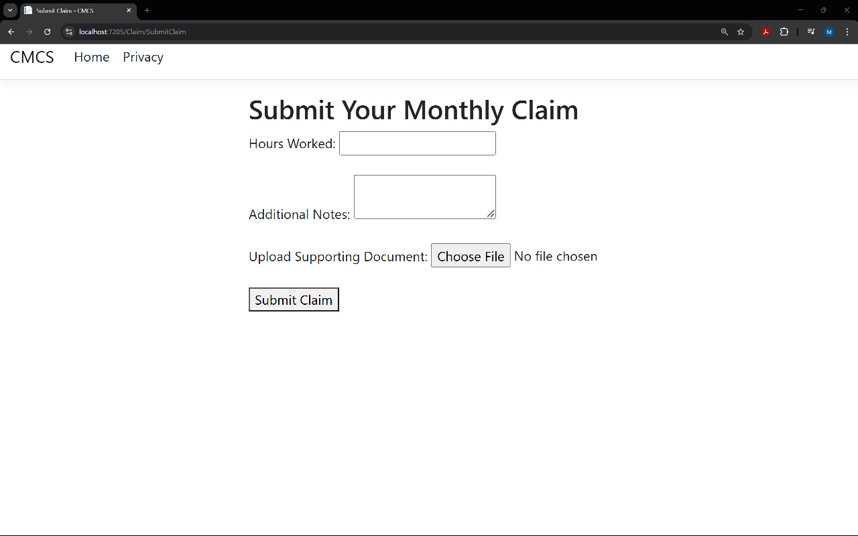

This shows that we are able to get documents from our device

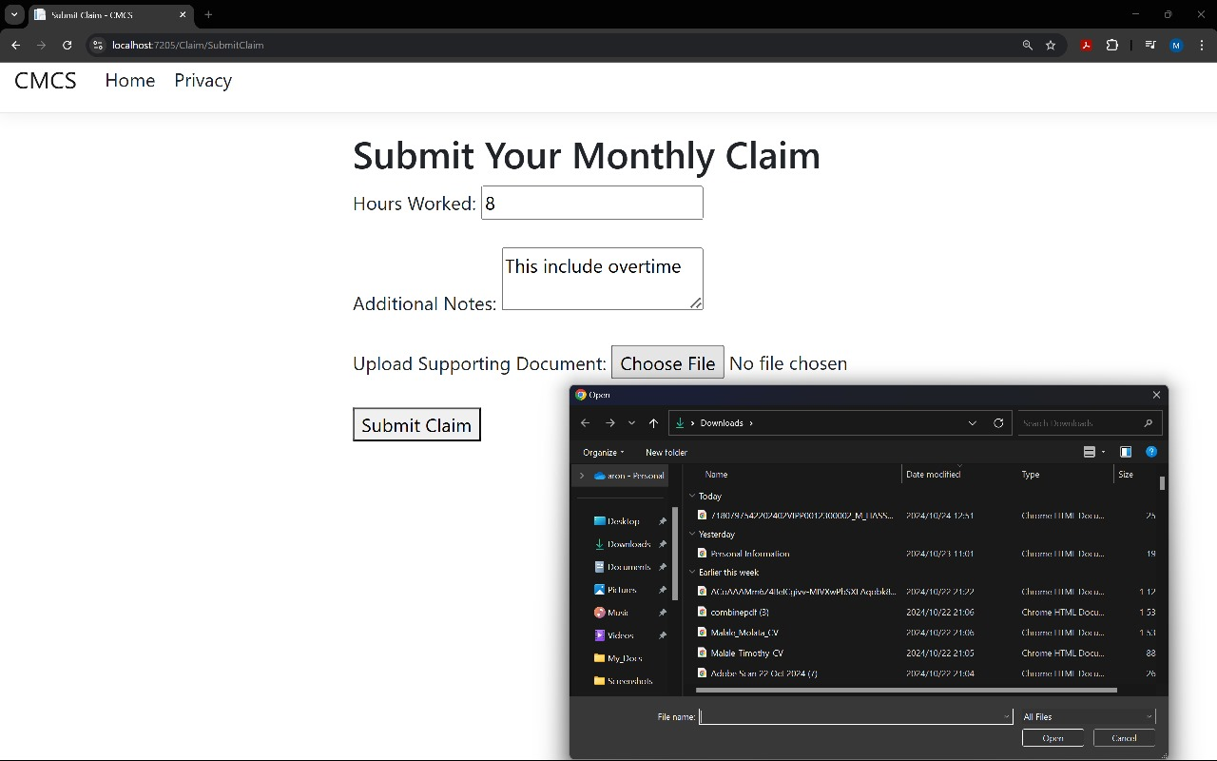

i managed to get the document from my device as you can see my document is visible.

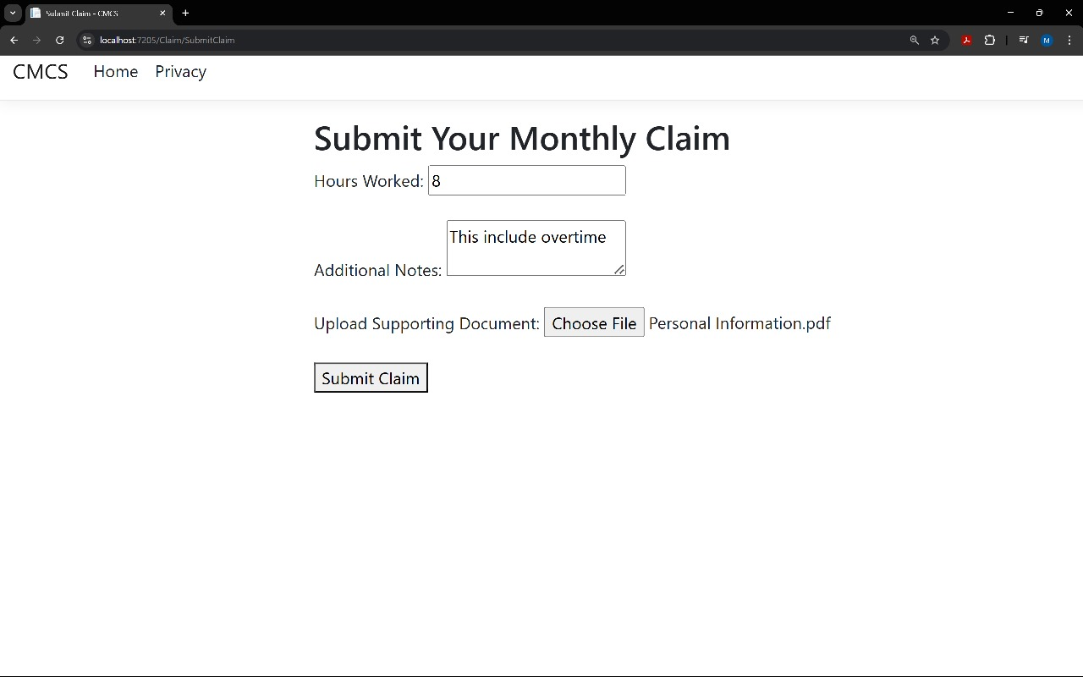

This is the submision

This is to check claim



